Steps for Restricted Area Violation:
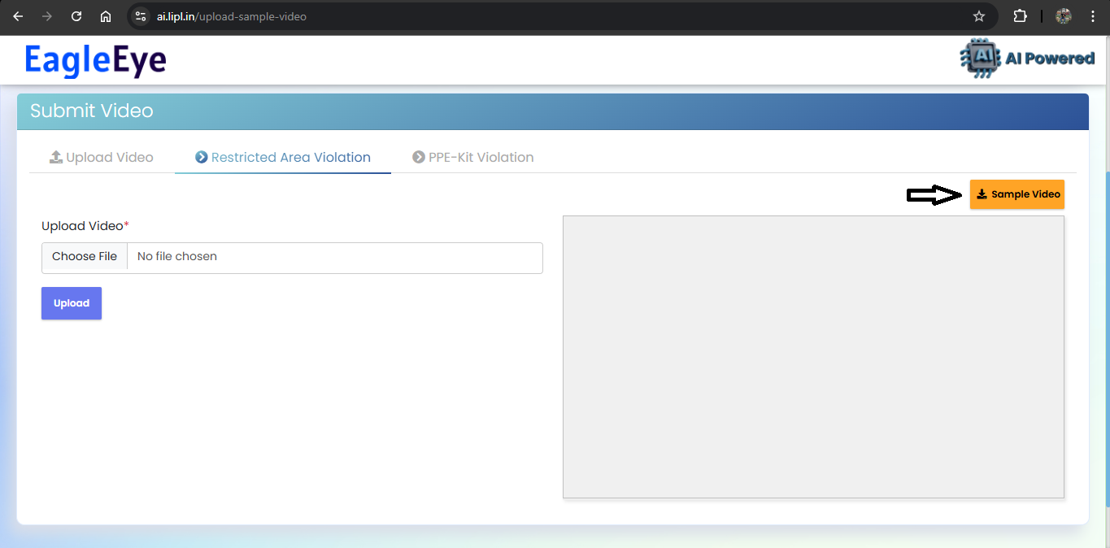
- Download the Sample Video.

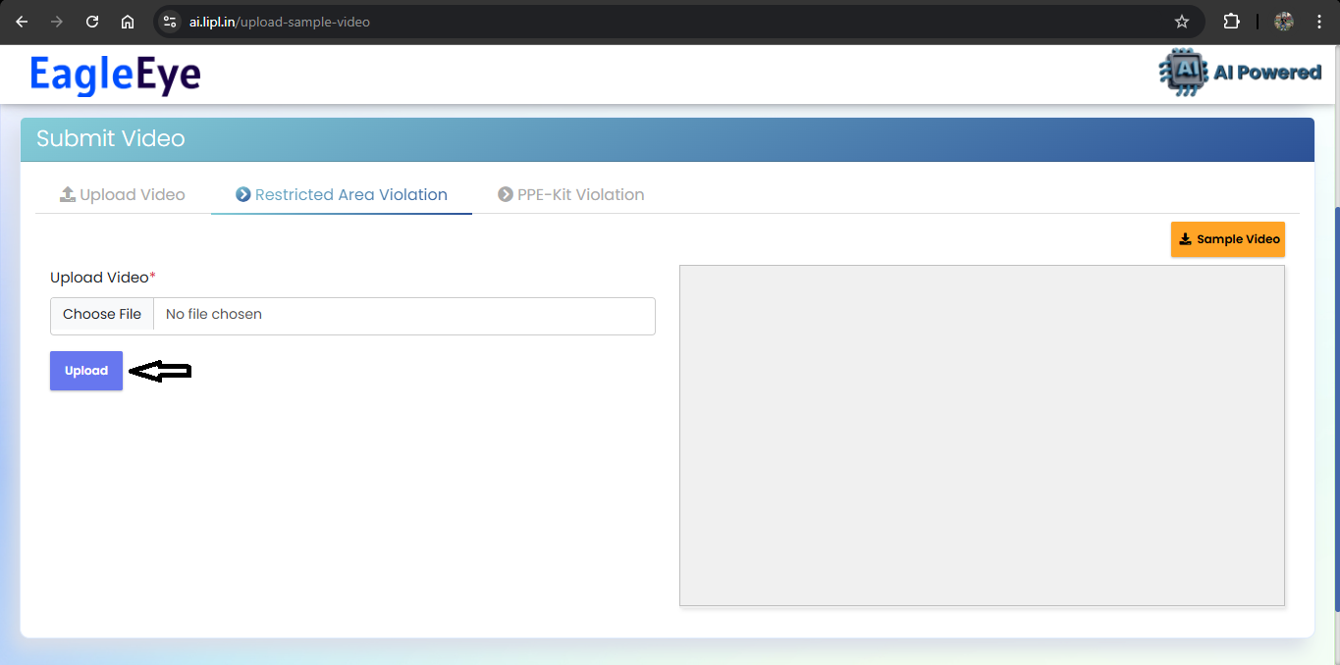
- Upload the downloaded video.

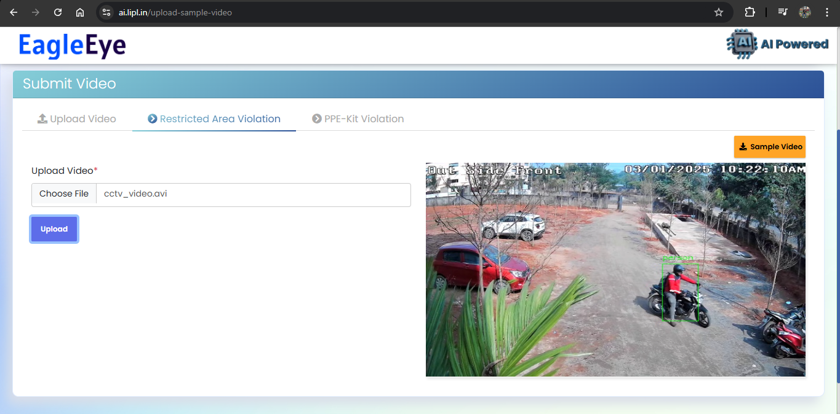
- After, uploading it would show preview of the uploaded video with the detection data like if any person detected in the restricted area or not. If detected, an alarm will be played.

Steps for PPE-Kit Violation:
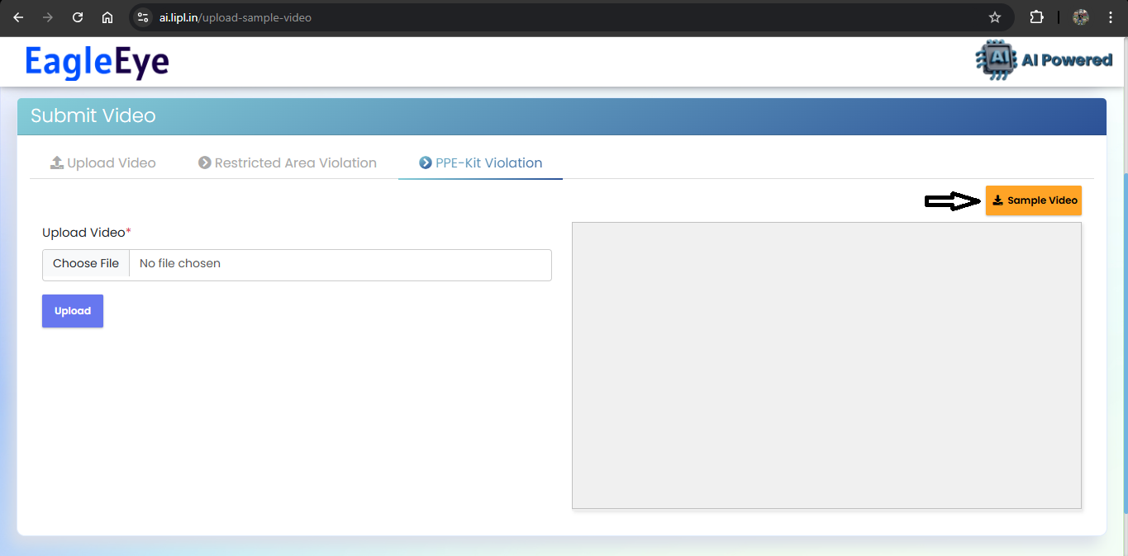
- Download the Sample Video.

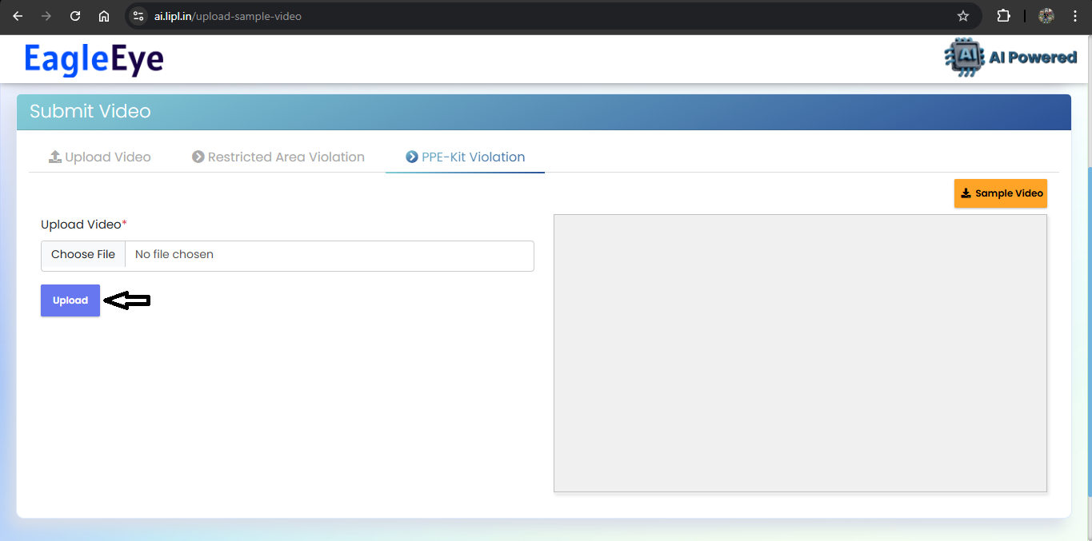
- Upload the downloaded video.

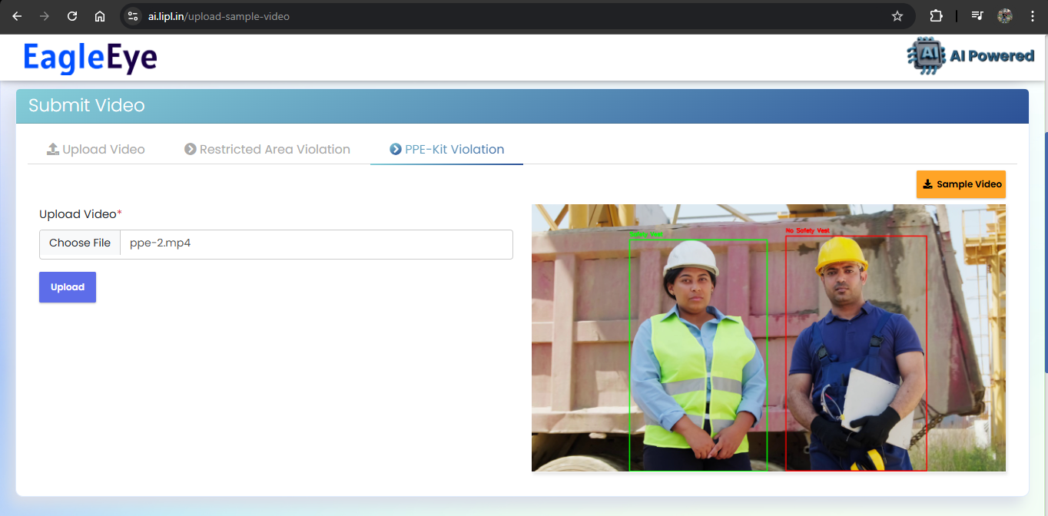
- After, uploading it would show preview of the uploaded video with the detection data like whether any person is wearing PPE Kit or not. If any person is not wearing PPE Kit, then it will show and an alarm will be played

- Also, along with it, it will also match the detected faces against the registered user faces and show if any matched user is found.
